Toward One Wisconsin 2021 Marketing Kit

CONFERENCE INFORMATION:
Toward One Wisconsin 2021 – A Conference on Equity, Diversity and Inclusion
Conference Theme: Building Bridges and Breaking Barriers
October 12-13, 2021 - FULLY VIRTUAL CONFERENCE*
Information at www.t1w.org
*Due to concerns about the spread of COVID, conference organizers have shifted the conference to an all-virtual format

T1W QUICK FACTS:
- 3rd annual Toward One Wisconsin Conference
  - First conference took place in Milwaukee in 2019
  - Second conference was fully virtual in 2020 (due to COVID)
- Looking to have 600+ attendees
- T1W 2021 was originally set to be in Eau Claire – due to COVID-19 it will be a fully virtual conference
- 800 virtual attendees in 2020
- 20+ sponsor/partner organizations
- 75+ people involved in the planning of the conference - Includes individuals and organizations from around the state and the Eau Claire region
- 3 nationally acclaimed plenary speakers – Kao Kalia Yang, Dasha Kelly Hamilton, and Jelani Cobb
- 100+ presenters in 48 breakout presentations

T1W 2021 Marketing Language:
Wherever you are on your Diversity, Equity and Inclusion (DEI) journey, there’s something for you at Toward One Wisconsin. Whether you’re just starting out and overwhelmed, or you’re a leading activist in your community, this conference will provide best practices, insights and implementation tools to help you take the next steps. Across all sectors of business and life in Wisconsin, parallel efforts are underway to prioritize DEI. We may be in different places based on the diversity of our experiences, but we’re all traveling the same journey: Toward One Wisconsin. Please mark your calendar and join us virtually October 12-13 to continue to exchange ideas, dialogue, reflect, connect, and take action!

PLENARY SPEAKERS:
Kao Kalia Yang
Kao Kalia Yang is a Hmong-American author, filmmaker, teacher, and co-founder of Words Wanted, a company dedicated to helping immigrants with writing, translation, and business services.

Yang’s first book, The Latehomecomer: A Hmong Family Memoir, details her family’s move from the Ban Vinai Refugee Camp to Minnesota in 1987. The Latehomecomer was the winner of two Minnesota Book Awards, a finalist for the PEN USA Award, and was the first Hmong-authored book to gain national distribution from a literary press.

Dasha Kelly Hamilton
Dasha Kelly Hamilton is a writer, performance artist and creative change agent, applying the creative process to facilitate dialogues around human and social wellness. She currently serves as the Poet Laureate for the City of Milwaukee and the State of Wisconsin.

As an Arts Envoy for the U.S. Embassy, Kelly Hamilton facilitated community building initiatives in Botswana, Toronto, Mauritius, and Beirut. Her touring production, “Makin’ Cake,” engages communities in a forward dialogue on race, class and equity.

Jelani Cobb
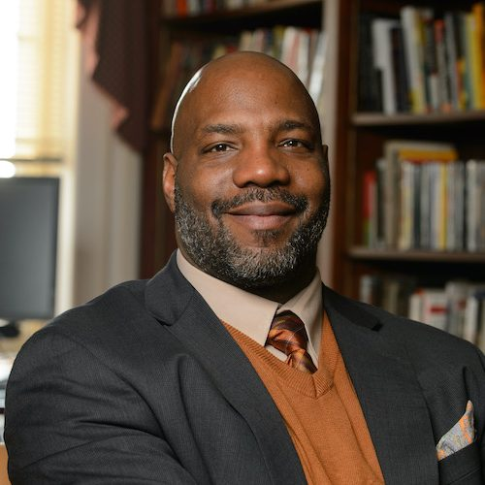
Jelani Cobb is a New Yorker staff writer, FRONTLINE correspondent, and Columbia University’s Ira A. Lipman Professor of Journalism. Cobb’s writing on race, history, justice, and politics earned him the Hillman Prize of opinion and analysis journalism.

Cobb is featured prominently in Ava DuVernay’s 13th, the Oscar-nominated documentary about mass incarceration of black Americans and the Thirteenth Amendment.

ARTIST IN RESIDENCE:
Dorothy Chan
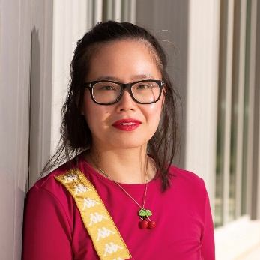
Dorothy Chan is an Assistant Professor of English at the University of Wisconsin-Eau Claire, Editor Emeritus of Hobart, Book Reviews Co-Editor of Pleiades, and Co-Founder and Editor in Chief of Honey Literary Inc., a literary arts organization.

Chan has authored BABE, a forthcoming chapbook, Revenge of the Asian Woman (2019), Attack of the Fifty-Foot Centerfold (2018), and Chinatown Sonnets (2017). She is two-time finalist for the Ruth Lilly and Dorothy Sargent Rosenberg Poetry Fellowship, a finalist for the Lambda Literary Award in Bisexual Poetry, and recipient of the Philip Freund Prize in Creative Writing from Cornell University. Her work appears in POETRY, The American Poetry Review, Academy of American Poets, and elsewhere.

CONFERENCE VISION:
The Toward One Wisconsin Conference aspires to create and sustain a statewide culture that understands that diversity, equity, and inclusion are essential to the state’s continued excellence. We recognize that the pursuit of excellence intersects with a commitment to diversity in all sectors. We envision an inclusive Wisconsin that brings marginalized to the center so that every person has the opportunity to use their unique experiences and backgrounds together—to spark solutions that create a better, healthier Wisconsin.

AUDIENCE:
We expect a diverse attendance including but not limited to representatives from birth-K-12, higher education, academia, business and industry, state and local workforce development, youth programs, health professions, vocational rehabilitation, chambers of commerce, non-profit organizations, government, community and neighborhood associations, and faith-based groups.
PRESS RELEASES:
- Toward One Wisconsin 2021 Announces Virtual Attendance Option and COVID-19 Update
- Helping single super moms with academic success
- How to Depolarize America – and yourself!
- Just three months away from Wisconsin’s premiere inclusivity conference
- Meet the T1W 2021 plenary speakers
- Jelani Cobb announced as newest T1W 2021 plenary speaker
- 4th Annual Workforce Solutions Summit
- T1W 2021 announces new conference co-chair and plenary speaker
- Toward One Wisconsin 2021 announces first plenary speaker
- Save the date for Toward One Wisconsin 2021!

MULTIMEDIA:

Flyer:
Conference Flyer Link

Logos:
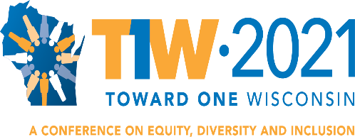
JPG – PDF – PNG

Photos:
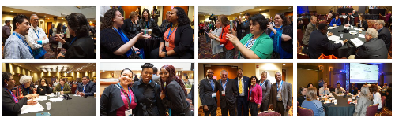
2019 Conference Photo Set

Videos:
- Dasha Kelly Hamilton - Toward One Wisconsin 2021 Promo Video
- Dave Anderson Snippet - Toward One Wisconsin 2021
- Toward One Wisconsin Conference Co-Chair Jessica Cavazos
- Kao Kalia Yang: Toward One Wisconsin 2021 Plenary Speaker
- Toward One Wisconsin 2020 Recap Video

MEDIA CONTACT:
Luke Rudolph
Wisconsin Institute for Public Policy and Service
Marketing Communications Coordinator
Mobile: 715-212-0537
lrudolph@uwsa.edu

