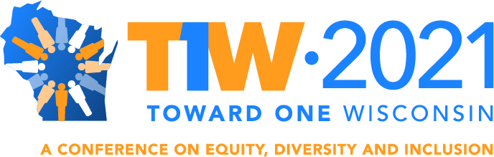

T1W CONFERENCE 2021: The Northwest region of Wisconsin and the Eau Claire community have enthusiastically stepped forward to host the Toward One Wisconsin Conference to be held October 12-13, 2021 with the theme Breaking Barriers, Building Bridges. Wherever you are on your Diversity, Equity and Inclusion (DEI) journey, there’s something for you at Toward One Wisconsin. Whether you’re just starting out and overwhelmed, or you’re a leading activist in your community, this conference will provide best practices, insights and implementation tools to help you take the next steps. Across all sectors of business and life in Wisconsin, parallel efforts are underway to prioritize DEI. We may be in different places based on the diversity of our experiences, but we’re all traveling the same journey: Toward One Wisconsin. Please mark your calendar and join us in Eau Claire to continue to exchange ideas, dialogue, reflect, connect, and take action! [Note: If COVID persists as a public health danger, planners are prepared to shift the conference to a virtual format.]

CONFERENCE TRACKS: The conference will feature four tracks where attendees will discover collaborative and innovative approaches, best practices, cutting edge research, and/or success stories that address job entry, creating united communities that welcome all residents, embracing a healthy climate for youth in our schools and neighborhoods, and promoting health equity initiatives across Wisconsin:

Track I: Increasing Opportunities for Inclusion in Wisconsin’s Workforce
Track II: Creating Inclusive Communities
Track III: Cultivating Equity in Education
Track IV: Building Health Equity in Wisconsin

CONFERENCE PURPOSE: The conference seeks to amass and coordinate knowledge in an unprecedented collaborative project that will draw on Governor Evers’s commitment to prioritize the work of diversity, equity, inclusion and access throughout Wisconsin, as well as support the creation of a statewide network of individual leaders, non-profit organizations and employers determined to empower and employ the full talent of all who live here in Wisconsin.

CONFERENCE GOALS:
      - Address how to better support marginalized people who have been disproportionately affected by COVID-19.
      - Bridge the gaps to unite our communities and residents and demonstrate how community partnerships and collaboration between private and public sectors work.
      - Showcase local and regional efforts to bring about change.
      - Encourage attendees and provide tools to be change agents in their communities.
      - Influence the state of Wisconsin to address structural challenges related to equity, diversity, and inclusion.

CONFERENCE OUTCOMES:
- Build greater awareness on the intersection between inclusion and economic, social, and emotional health of communities, workforce, youth, and under-served populations in Wisconsin.
- Produce a comprehensive strategic report with performance measures and actionable recommendations around each Track for state and local governments, businesses, communities, educational institutions, health systems, and non-profit organizations
- Create and sustain lasting networks centered in communities across Wisconsin to support local efforts at bringing about meaningful change.

CONTACT: For more information, contact Sharon Hunter, Conference Coordinator, Wisconsin Institute for Public Policy and Service, University of Wisconsin System, at (715) 261-6368 or shunter@uwsa.edu.

